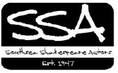
Billboard
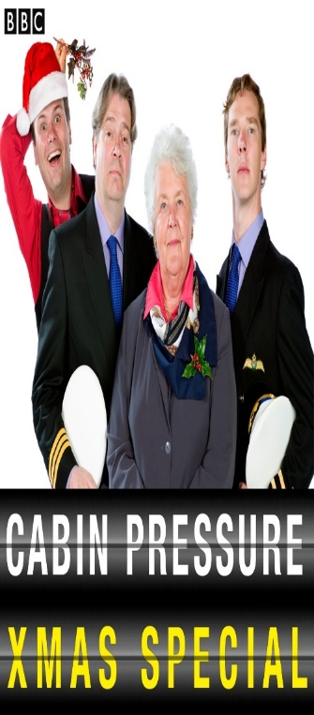

Cabin Pressure Christmas Special
Yes we are back by (almost) popular demand doing three more episodes of the wonderful Radio 4 series Cabin Pressure. If you didn’t come before you are in for treat.
This time, as it’s Christmas (and my Cabin staff want to get drunk) we suggest that you bring your own drinks, soft and hard! There will be a little in-flight catering (the odd mince pie and twiglet) which Arthur will be preparing in the galley between performances – so don’t expect too much!
This is an in-house so that means it is available to paid up SSA acting members and SSA Friends, plus their guests. We don’t charge a fee to get in but if you could make a donation of about £5 to the SSA funds that would be as Arthur would say “Brilliant!”
Anyway the details are as follows –
18th December at the HQ, flight departs at 19:30
Make sure you let me know if you are coming and I will book you a seat. Last time we sold out and tickets are already going fast. So text me on 07989429848 or send a note to robnotbob120@gmail.com and I will put you on the passenger list.

The Winter’s Tale
We are very excited to announce: our next major production will be:
"The Winter's Tale" by William Shakespeare! Tragical. Comical. Magical.
The Winter's Tale" is exotic and magical, not quite real, like a dream, a 'grown-up fairy tale' of jealousy and suspicion, but also a tale of redemption, reconciliation and joy. It begins in tragedy but transforms to comedy and a happy ending.
Your director will be the lovely Mr Nic Downes … who is pretty darn good!!
Performance Dates - 6th to 9th April 2016 Venue: The Square Tower
Expo – Wednesday 25th November 19:30 at the HQ
Audition dates TBC Rehearsals will start in January

HQ Clean Up
Calling all SSA members. OK not the most exciting social event of the year but it’s time to give our HQ a bit of TLC.
Some of you may know that Little Squirrel Nutkin chewed through the water tank which caused a flood that stained the walls and caused a horrid mess!!!
So if anyone is free please come and join us, painting, cleaning, tip runs and general clear up. The more the merrier, and the quicker we will get it done.
If you have brushes, or cleaning stuff that you can bring along that would be lovely.
Saturday 21st November at 10:00 at the HQ … err obviously!!

The Merry Wives of Windsor - Review
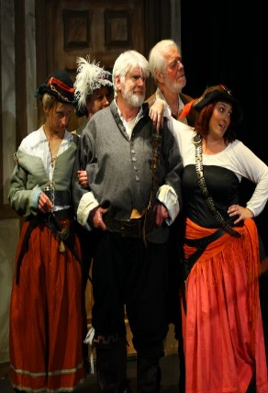
“Although one of Shakespeare’s better known comedies, it’s over-long and not a ‘laugh out loud’ show, so Director Vincent Adams did a good job in holding the audiences attention , assisted by some sparkling performances, particularly those of the Merry Wives themselves (Sarah Parnell as Mistress Ford and Paula Bartlett as Mistress Page).
Written supposedly at the request of Queen Elizabeth 1 who wanted the character of Sir John Falstaff to have another outing, it’s a tale of drunkenness, lechery, cuckolding, gullibility and jealousy. As the instigator of nearly all these was SSA regular Nick Downes, marvellously at ease as the impecunious scheming knight, with Lauren Farnhill excellent as Mistress Quickly, housekeeper to the bizarre Frenchman Dr. Caius (Jackson Davies).
But top honours must go to Tony Course as Frank Ford, whose rage and jealousy at the thought of being cuckolded reached almost Basil Fawlty-like proportions. A most enjoyable evening”.
Ed Howson

The Dodgy Old Boiler and Your Subs
A bit of potential bad news is that thanks to evil Squirrel Nutkin (see HQ Clean Up!) the boiler got filled with water where it shouldn’t be filled with water and may now be knackered. So it could be that we have to get a new one – apparently people got a little chilly while rehearsing Merry Wives. This means that if you haven’t paid your subs could you sort it out please.. Paula especially likes direct debit or standing orders or whatever it is. If you do have your subs sorted out if you could find it in your heart to increase them a bit (a pound or two a month for example) that would be fantastic.

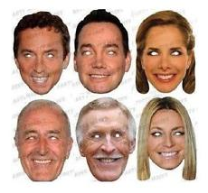
Strictly Cometh Shakespeare
I (that’s me Rob) have put forward an idea for the Shakespeare Festival that is happening next year in Portsmouth. It’s called Strictly Cometh Shakespeare and will (hopefully) be on the Friday (22nd of April) of the Shakespeare festival week at a venue (yet tbc) that will definitely have a bar!
The idea, very briefly, is that we (the SSA) and other drama groups in Portsmouth – CCADS, Humdrum and Collingwood RSC are all (sort of) on-board – pick a Shakespeare play and prepare three short (max 5 mins) scenes from it. One tragical, one magical and one comical. We will do a scene and then get comments and scores from some judges, followed by a public vote, followed by some drinking, followed by doing it all again! At the end of the evening all the votes are counted and a winner is announced – who will of course be Shakespeare!!!
If anyone is interested in helping me organise this – or is keen to direct or act in the SSA’s contribution please let me know… it’s going to be great… trust me Neil… it will honest!

Other Productions
So not only do we have The Winter’s Tale in April, we also have Murder in the Cathedral in October and a slot booked for Hayling in November. We don’t have a show yet for Hayling so if you have a hankering to get your directorial hands dirty talk to one of the Committee about your ideas.
If there is anything else you want to do during the year just ask and we will do all we can to help you get it on!

